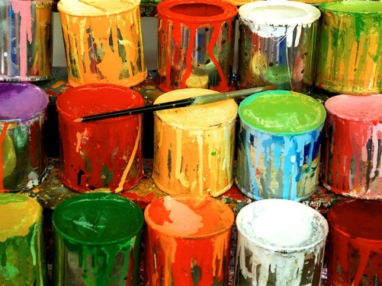
Used Paint Drive Collection to Support
Matthew 25 Ministries
WHO: Sponsored by the G.A.T.E.S. Program

WHEN: Parent-Teacher Conference Nights
Thursday, 2/5/15, at 3:30 pm and 5:00-8:30 pm, and
Tuesday, 2/10/15, at 3:30 pm and 5:00-8:00 pm

WHERE: Drop-Off Stations at LCE, MNE, and NRE inside the Front Doors by the Main School Offices

WHAT: 1-Gallon and 5-Gallon Latex Paint Containers
Original Containers with Original Labels Only
No Empty or Almost Empty Cans Accepted

WHY: Help us “PAINT A BRIGHTER FUTURE”

Matthew 25: Ministries’ Rainbow Paint Re-blending Program rescues and reuses leftover paint to provide a high-quality, re-blended/recycled latex paint to the poor throughout the U.S. and around the world.

Rainbow Paint helps low-budget non-profits, schools, and public facilities complete maintenance, rehab, and upgrade projects at a low cost. It enhances the quality of life for recipient individuals and organizations by improving and beautifying physical surroundings. One such endeavor is an on-going development project in Nicaragua which Matthew 25 is involved in. This project provides proper housing and sanitary conditions to impoverished families living in rural Nicaragua. The houses are completed with a protective coat of paint from Matthew 25: Ministries’ Rainbow Paint Re-blending Program.

Matthew 25: Ministries’ Rainbow Paint Re-blending Program reduces the amount of hazardous waste being deposited in landfills, public waterways and sewer systems. It also helps prevent poison exposures through accidental human contact or consumption of excess and leftover paint.

PLEASE DONATE!

