**New Richmond**

**Exempted Village School District**

**Preschool Registration and Screening**

**2020-2021**

kidrow_b

In a normal year, parents of preschool age children would contact the school building and schedule a time to participate in the preschool screening process in May. Because of COVID-19, registration of preschoolers will be taken through the registration portal on the New Richmond website.

The online registration process does not require documentation to be provided. Preschool registration only assures you of a spot in the screening process; therefore documents are not needed when you register online.

Appropriate documentation **must be** provided at the in-person screening sessions. These sessions will be schedule after the COVID-19 stay-at-home order has been lifted.

The following documents are needed for preschool screening and enrollment:

-Original Birth certificate -Immunization records

-Social Security Card -Custody Papers (if applicable)

-Proof of residence (current driver’s license or state ID, and utility bill)

Preschool tuition is based on the amount of monthly family income. Parents must also bring one of the following items for verification of income to the preschool screening:

-W-2 - AFDC number

-Income tax return - food stamp case number

**Preschool FAQ**

**1. What is screening?**

Preschool screening is a process to identify those 3 and 4 year-old children who may be eligible to attend our preschool program. The multi-step screening process includes hands-on activities for the children to complete, as well as a parent interview.

**2. Who will screen my child?**

The screening team is made up of current preschool teachers, instructional assistants, and speech pathologists and/or occupational therapists.

**3. Why does my child need to be screened?**

Our preschool at New Richmond is funded by monies allotted through a federal grant. The requirements of the grant are very specific in regards to class makeup. Certain requirements include boy/girl ratio, paying students/income eligible students, and 3 year-old students/4 year-old students. The screening process assures best classroom placement for each child as well as helps us identify those children who may need special education services.

**4. Who is eligible to attend screening?**

Screening for our preschool program is limited to children who live in the New Richmond School District. Children who live in the district, including Monroe and Locust Corner, may attend screening. We also require that each child being screened, will be age 3 on or before August 1. Our preschool program expects eligible students to be toilet trained by the time school starts.

**5. My child is almost three, may he screen?**

Yes – IF your child will be 3 by August 1. Our screening process and school- year curriculum is designed for children ages 3 and 4. Children under age 3 must wait until the following year to screen.

**6. What do I need to bring to screening?**

A copy of the following paperwork must be presented before your child is eligible to screen:

Original Birth certificate Immunization records

Social Security Card Custody Papers (if applicable)

Proof of residence (current driver’s license, or state ID, and utility bill)

Bring one of the following items for verification of income:

(W-2, Income tax return, AFDC number, or food stamp case number)

**7. Where does the screening take place?**

All screenings take place at the building of attendance, either Locust Corner or Monroe Elementary. Each parent will enter the building at the main door by the office, enter the office and check in. A volunteer will escort you and your child to the screening area.

**8. How long does the screening take?**

Depending on the cooperation level of the child, and the how many families are waiting, screening can take anywhere from 30 minutes to one hour.

**9. How do I know if my child is accepted into the Preschool?**

After the screening process, you will receive one of two letters; an acceptance letter into the program or a waiting list letter. If your child is accepted into the program you will receive detailed information and an entrance packet that must be completed before the school year begins.

**10. Does New Richmond have multiple preschool classrooms?**

Yes. The New Richmond Exempted Village School District has two preschool classrooms at Locust Corner and Monroe Elementary. One of the classrooms is an integrated class with some children with disabilities and the other is an Early Childhood classroom with all typical students. All classrooms are Step Up To Quality licensed by the Ohio Department of Education.

The district preschool program uses the Ohio Academic Content Standards. They have bus transportation to and from school. All classrooms have one licensed classroom teacher and one instructional assistant as well as a highly qualified support staff, including Speech Pathologists, Occupational and Physical Therapists, and School Psychologists. All classrooms require an 85% attendance rate.

Both programs have two half-day sessions. These sessions are established by geographic areas for transportation efficiency. Sessions are scheduled in the A.M. from 8:45 a.m.-11:45 a.m. and the P.M. from 12:30p.m.-3:30p.m. Lunch is provided.

**11. What are the differences between the integrated preschool class and the Early Childhood class?**

**Early Childhood Integrated**

Class Size 16 typical students 8 typical & 8 special needs students

**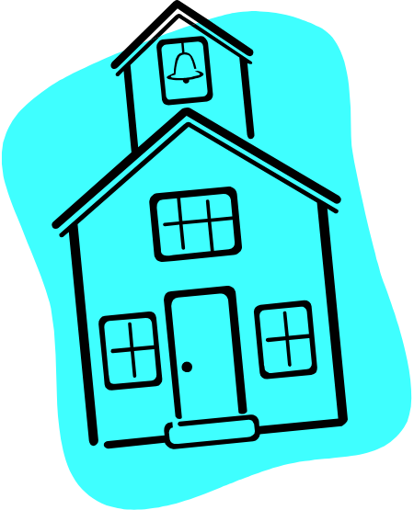**

This information was designed to provide general information regarding the New Richmond Exempted Village District Preschool Program. Specific questions will be answered on an individual basis as the need arises. You may contact the John Frye, preschool director or Rebecca Brock, preschool supervisor at 553-2616 or 753-8359.